Device Manufacturing

Signal Generator

Bill of Materials:
Part Name | Amount
100Ω Resistor | 1
10Ω Resistor | 8
1MΩ Resistor | 10
270kΩ Resistor | 10
270Ω Resistor | 1
74HC4051 Analog Multiplexer | 1
ESP32-38PinWide | 1
L293D H-Bridge | 1
MicroSD Card Module | 1
Piezo Speaker | 1
Red (633nm) LED | 1
RioRand LM2596 Buck-Buck Converter | 1
Voltmeter (3 wire) | 1
Breadboard | 1
Solderless Connectors | 1
High Voltage Power Supply | 1
Power Connector | 1
5V Power Supply | 1

Assembly Instructions: Assemble breadboard according to the attached Circuit Diagram. The included fritzing file may also be consulted for an interactive circuit diagram. After circuit assembly, load the attached Estim_Device.ino code onto the ESP32 microcontroller.

Testing Instructions: Connect to web server GUI by connecting computer to EStim WiFi network and searching for the IP http://192.168.4.1/ in a web browser. Turn on electrical stimulation. Current and well resistance values should be negative, indicating incomplete circuits for each well. Complete circuits by connecting outputs to electrodes with 100Ω resistors. Check values for voltage, current, and well resistance on web server GUI. Current values should now be positive and well resistance should read ~100Ω. Refreshing the webpage will refresh the measured values. Tune voltage by turning the control screw on LM2596 Buck-Buck Converter. Measured voltage on the Web server GUI will be offset from the voltage measured on the voltmeter due to h-bridge attenuation.

Electrodes

Bill of Materials:
Part Name | Amount
PLA-HP Black Printing filament | 1
Mold Base (3D printed part) | 1
Electrode Holder (3D printed part) | 1
Electrode Pins Template (3D printed part) | 1
Carbon graphite electrodes 2cmX2cm) | 8
Long breadboard header pins | 8
Breadboard wires | 8
Sylguard 184 kit | 1
6-well tissue culture treated plate lid | 1
8 conductor wire | 1

Assembly Instructions:
3D Printing
- Using PLA-HP black filament, print 1 Mold Base and 1 Electrode Holder
- Using PLA or PETG filament, print 1 Electrode Pins Template

Load the Electrodes into the Mold
- Load the 2cm X 2cm electrodes into the electrode holder, placing one in each slot (see below)
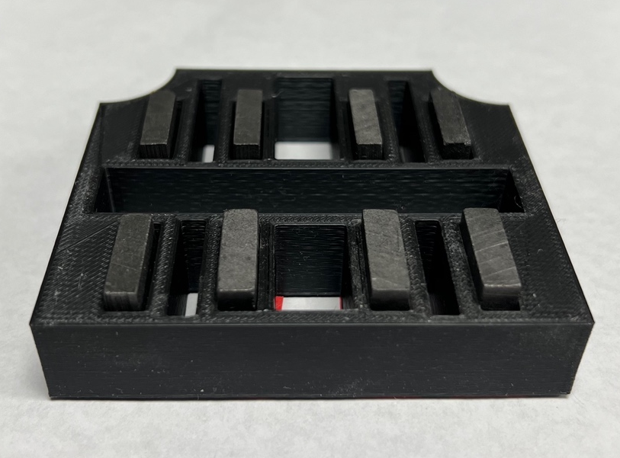
- Push all electrodes to be flush with the holder on one side; the more even side of the electrode should be on the flush side, as these will be submerged in the well
- Cover the electrodes with tape on the flush side, flip the holder, and press the electrodes into the tape to secure them in place

PDMS Prep
- Using a Sylguard 184 kit, mix PDMS backbone /crosslinker solution at 1:10 ratio
  - 1g of PDMS:106 µL crosslinker
  - For a four-electrode mold, use approximately 26 grams of elastomer
- First pour the elastomer slowly into a weigh boat, recording the actual weight used
- Calculate the amount of crosslinker needed using the relationship above
- Add the crosslinker using a pipette, pipetting slowly to account for viscosity
- Mix thoroughly in the weigh boat before placing in a vacuum desiccator to degas for 15 min at room temperature
PDMS Casting
- On a covered benchtop, pour the PDMS into the mold
- Place the loaded electrode holder on top with the flush/ tape side facing upwards (see below)
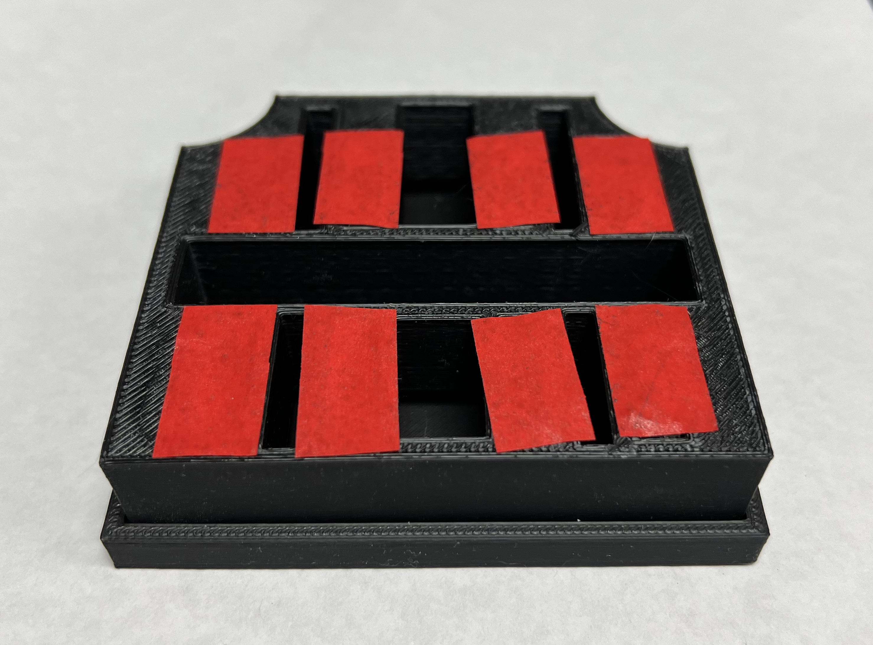
- Cast at 70 degrees Celsius for 5 hours
- Remove from oven and let cool overnight at room temperature
- To remove the electrodes from the mold, gently use tweezers and a lever motion to release the PDMS from the mold before pushing the electrodes out of the mold
- Clean the carbon electrodes using ethanol and a Kimwipe to remove excess PDMS and elastomer that has stuck to the sides

Wiring Prep
- Tape Electrodes Pins template onto the lid of a 6-well tissue culture plate
- Mark where the holes will be using a 0.8mm drill bit at points indicated by template
- Drill 0.8mm wide holes, being sure to carefully drill straight down (see picture)
- Place the electrodes into the plate and carefully line up the electrodes with the template

- Insert header pins to check that the holes were properly drilled and the electrodes are functional
- Solder wires to header pins and connect to electrodes

Sterilization
- Electrodes can be sterilized via autoclaving
- Plate lids may be sterilized via UV treatment (XYZnm for 30 min.)

